SwissCenter Installation
Windows Step-by-Step Guide

Author: Robert Taylor (Swiss)
Creation Date: 29th September 2004
Last Updated: 29th September 2004
Version: Draft A

Contents

Downloading the Software 3
Installing SwissCenter 4
Installing and Configuring MySQL 6
Installing MySQL 6
Configuring MySQL 8
Installing and Configuring PHP 9
Installing PHP 9
Configuring PHP 11
Installing and Configuring Apache 13
Installing Apache 13
Configuring Apache 16
Testing your Installed software 17
Configuring the SwissCenter Interface 18
Configuring the Showcenter to use the SwissCenter Interface. 20
Finished! 21

Downloading the Software
The following is a list of all the software that you will need for a successful installation of the SwissCenter interface for the Pinnacle Showcenter:
- SwissCenter
Download from http://www.swisscenter.co.uk/
Size – 1.5Mb
- MySQL 4.0 or above - Windows (x86) Installer
Download from http://dev.mysql.com/downloads/
Size - 24.6 Mb
- PHP 4.3.9 - ZIP Package
Download from http://www.php.net/downloads.php
Size - 6.79 Mb
- Apache 2 Webserver for Windows - Win32 Binary (MSI Installer)
Download from http://httpd.apache.org/download.cgi
Size - 6.39 Mb
Total download size is approximately 40 Mbytes.
Required Disk space for installation is approximately 110 Mbytes.

Please Note: The software supplied with your Pinnacle Showcenter does not need to be installed on your computer to allow you to use the SwissCenter. However, you will need the Pinnacle software installed if you wish to upgrade the Showcenter firmware.

Installing SwissCenter
Having downloaded the SwissCenter Zip file, installation is quite simple and only requires that you extract the contents of the zip file into the appropriate place.
The steps below show how to extract the file using the built-in zip handling features of Windows XP. If you are running Windows 2000 or NT, then you can use a program such as WinZip to extract the files instead.
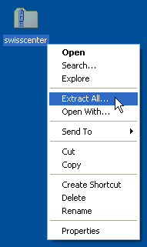 | Step 1  Locate the ZIP file that you downloaded, and right click on it to bring up the menu shown here. Select Extract All from the menu.

Step 2  Click Next. | - 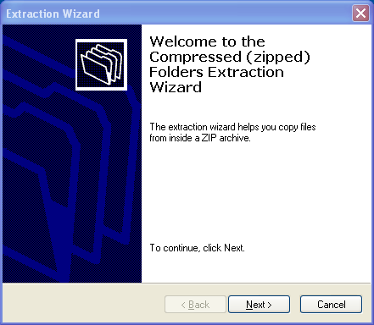

- 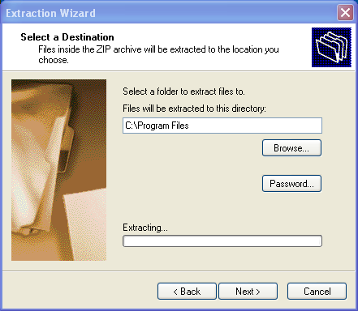 | Step 3  - Select a folder to extract the files into.  - This will be the folder into which the SwissCenter interface is installed, so it is recommended that you choose "C:\Program Files\SwissCenter" (or wherever you usually install your programs).  - Click Next once you have selected a folder.

Step 4  - Ensure that the Show Selected Files option is not checked and click Finish. | - 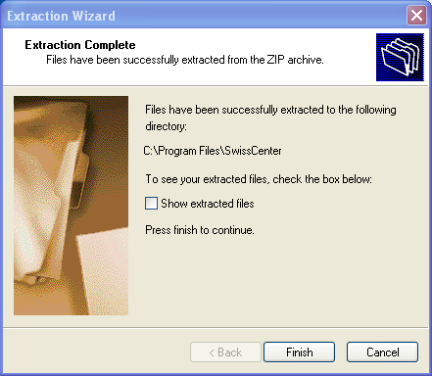

Information on how to configure the SwissCenter will be provided later in this document once all the other required software components are installed.

Installing and Configuring MySQL

Installing MySQL
Having downloaded the MySQL 4.0 (or above) Zip file you should extract it to a temporary folder (which you can delete after installation) and then double-click the Setup.exe file to launch the installer.
 | If you are using Windows XP, you do not need to extract the Zip file to a temporary folder first. You can simply double-click the Zip file to explore it and then double-click on the Setup.exe file to the installation program.

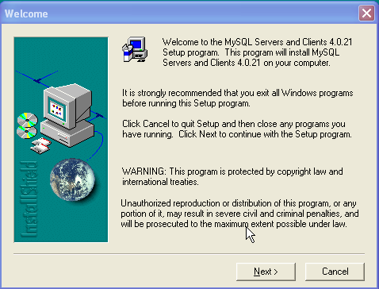 | Step 1  Click Next.

Step 2  Click Next. | 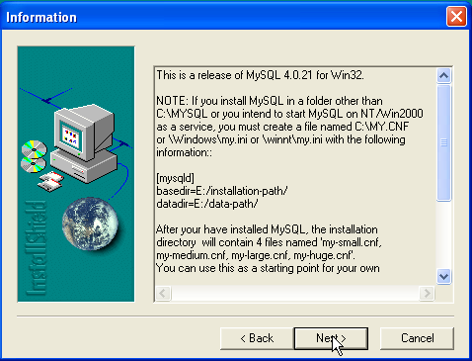

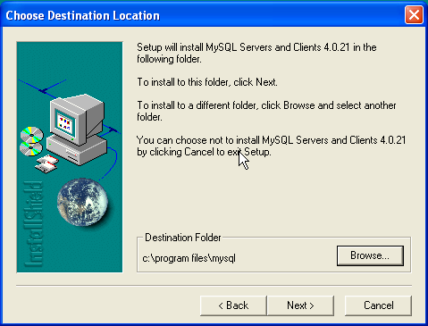 | Step 3  Choose a destination folder into which MySQL will be installed.  - It is recommended that you choose "C:\Program Files\MySQL" (or wherever you usually install your programs).  - Click Next.

Step 4  Choose the Typical Installation and click Next. | 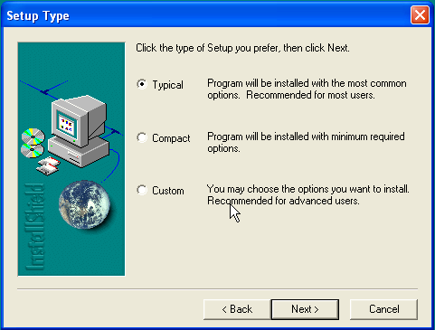

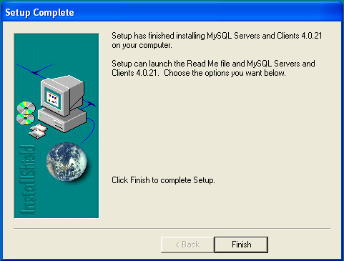 | Step 5  Click Finish.

Configuring MySQL
Although MySQL does not have a standard MSI installer, there are only two steps that you need to perform to configure MySQL and ensure that it is automatically started when Windows loads.
Step 1
Copy the text below into Notepad (or your favourite text editor) and save it as "C:\Windows\My.ini" Note that the path names are specified with forward slashed, not back-slashes.
[mysqld]
basedir=C:/Program Files/mysql
datadir=C:/Program Files/mysql/data
tmpdir=C:/windows/temp

[WinMySQLadmin]
Server=C:/Program Files/mysql/bin/mysqld-nt.exe
user=root
password=

If you installed MySQL into a different location then you should substitute the location you used in place of the C:\Program Files\Mysql.
Step 2
Click on the Start Menu and select Run. In the dialog box that appears, type the command exactly as it appears below (or cut and paste it) and click OK.
"C:\Program Files\MySQL\bin\mysqld-nt" –install
net start mysql

Again, If you installed MySQL into a different location, then you will need to substitute the location you used as in place of "C:\Program Files\Mysql"

Installing and Configuring PHP

Installing PHP
Having downloaded the PHP 4.3.9 Zip file, installation is quite simple and only requires that you extract the contents of the zip file into the appropriate place.
The steps below show how to extract the file using the built-in zip handling features of Windows XP. If you are running Windows 2000 or NT, then you can use a program such as WinZip to extract the files instead.
Please Note: You must download the ZIP version of the PHP installation, not the version that has been written as a windows installer. This is because the ZIP file contains a number of PHP extensions that are required by the SwissCenter and are missing from the windows installer version.

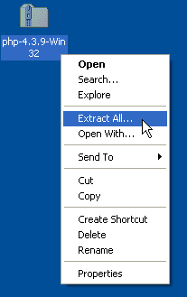 | Step 1  Locate the ZIP file that you downloaded, and right click on it to bring up the menu shown here. Select Extract All from the menu.

Step 2
Click Next.

- 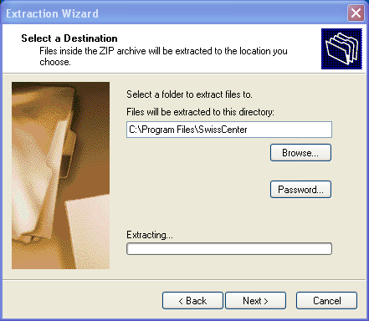 | Step 3  - Select a folder to extract the files into.  - This will be the folder into which PHP is installed, so it is recommended that you choose "C:\Program Files\" (or wherever you usually install your programs).  - Click Next once you have selected a folder.

Step 4  - Ensure that the "Show Selected Files" option is checked (for the next step) and then click Finish. | - 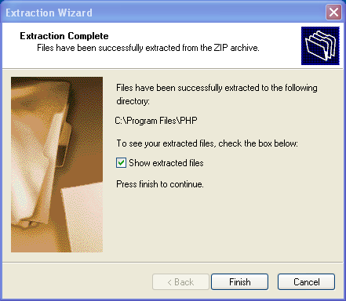

- 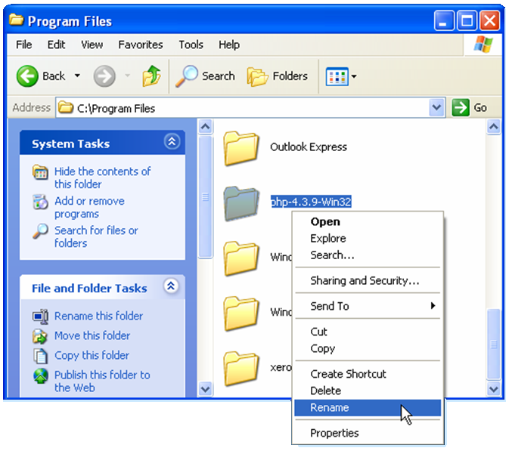 | - Step 5  - Finally, in the Explorer window that opens you need to either rename the PHP folder to something a little easier to remember, or make a note of the exact folder name.  - It is recommended that you rename the folder to "PHP" by pressing F2 or right clicking on the folder and selecting Rename from the context menu.  - Note: You may have to click "Show the Contents of this folder" if the files are hidden.

Configuring PHP
PHP is entirely configured from a single text file (the php.ini file), and there are only a few minor changes that you will need to make to the standard file.
Step 1
Load the file C:\Program Files\PHP\php.ini-dist into your favourite text editor (if you installed PHP into a different location then load the php.ini-dist file from that location instead).
Step 2
Next, you need to navigate down to the section of the configuration file that controls which PHP extensions will be enabled. The easiest way to do this is to perform a search for the text "Windows Extensions". The section of the document will look similar to that shown below:
;Windows Extensions
;Note that MySQL and ODBC support is now built in, so no dll is needed for it.

;extension=php_bz2.dll
;extension=php_cpdf.dll
;extension=php_crack.dll
;extension=php_curl.dll
;extension=php_db.dll
;extension=php_dba.dll
;extension=php_dbase.dll
;extension=php_dbx.dll
;extension=php_domxml.dll
;extension=php_exif.dll
;extension=php_fdf.dll
;extension=php_filepro.dll
extension=php_gd2.dll
;extension=php_gettext.dll
;extension=php_hyperwave.dll
;extension=php_iconv.dll
;extension=php_ifx.dll
;extension=php_iisfunc.dll
;extension=php_imap.dll
;extension=php_interbase.dll
;extension=php_java.dll
;extension=php_ldap.dll
;extension=php_mcrypt.dll
extension=php_mbstring.dll
;extension=php_mhash.dll
;extension=php_mime_magic.dll
;extension=php_ming.dll
;extension=php_mssql.dll
;extension=php_msql.dll
;extension=php_oci8.dll
;extension=php_openssl.dll
;extension=php_oracle.dll
;extension=php_pdf.dll
;extension=php_pgsql.dll
;extension=php_printer.dll
;extension=php_shmop.dll
;extension=php_snmp.dll
;extension=php_sockets.dll
;extension=php_sybase_ct.dll
;extension=php_w32api.dll
;extension=php_xmlrpc.dll
;extension=php_xslt.dll
;extension=php_yaz.dll
extension=php_zip.dll
Notice that there are a number of modules that I have highlighted in red. Make sure that those lines in your file match the ones above and do not have a semi-colon at the beginning.
Step 4
Using the Search function, locate the line which reads as follows
extension_dir = "./"
Change it to read:
extension_dir = "./extensions"
Step 5
Using the Search function, locate the line which reads as follows (note that there may be several lines which look similar to this one, but the one that you should locate does not have a semi-colon at the beginning of the line):
error_reporting = E_ALL & ~E_NOTICE
Change it to read:
error_reporting = E_ERROR
Step 6
In your text editor, go to the File menu and select Save As. Now save the file into your Windows folder (C:\Windows) with the name php.ini (Note that the "-dist" is omitted from the filename).

Installing and Configuring Apache

Installing Apache
Having downloaded the Apache installer, double click the executable to launch it and you will be presented with the following screen:
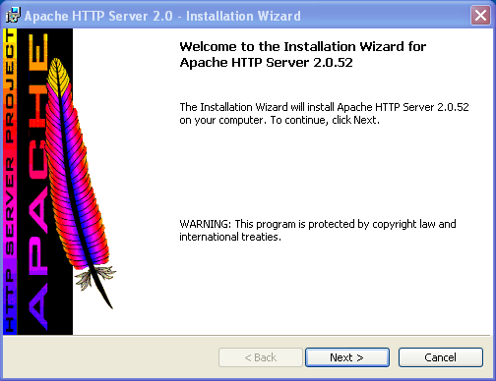 | Step 1  Click on Next and you will be presented with the License Agreement

Step 2  Of course, you plan to abide by the license agreement, so select I accept the terms in the license agreement and click on Next. | 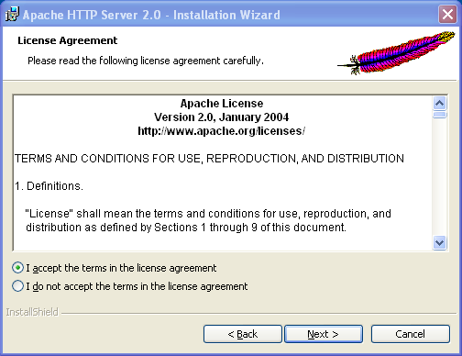

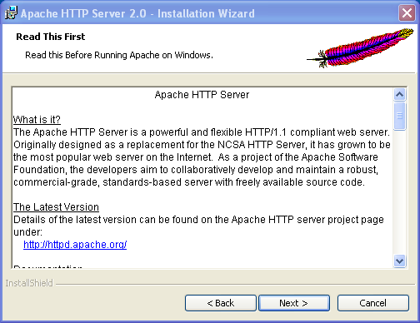 | Step 3  After reviewing the information (or not) click the Next.

Step 4  For both the Network Domain and the Server Name enter the name of your machine. If you don’t know what your machine’s name is then enter "localhost" instead (the Showcenter will access the webserver by IP address anyway, so it really doesn’t matter).  Enter your email address into the Administrator’s Email Address, leave the Programs and Shortcuts selection set to "for All Users" and click on Next. | - 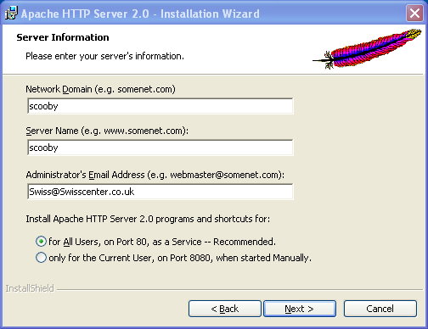

- 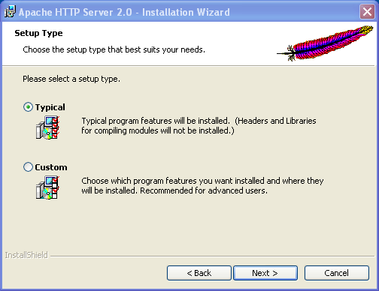 | - Step 5  - Leave the setup type set to Typical and click on Next.

Step 6  - Change the installation folder only if you need to install Apache to a different location, and then click on Next. | - 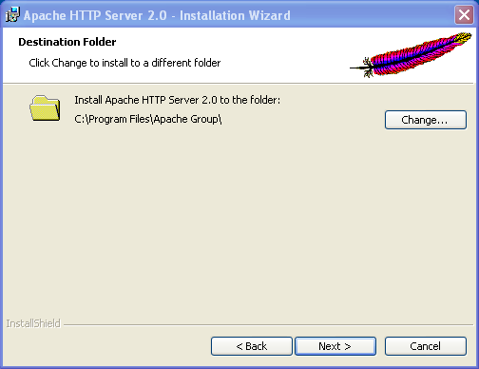

- 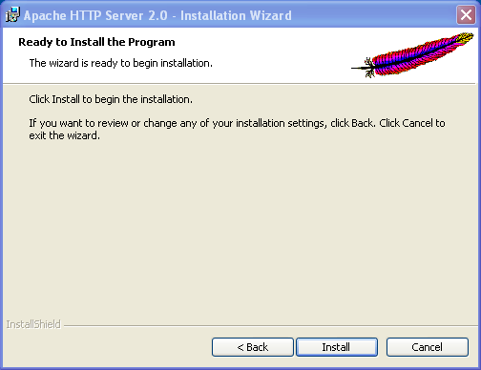 | - Step 7  - Click on Install and wait a couple of minutes for the installation to complete.

Step 8  Click Finish. | - 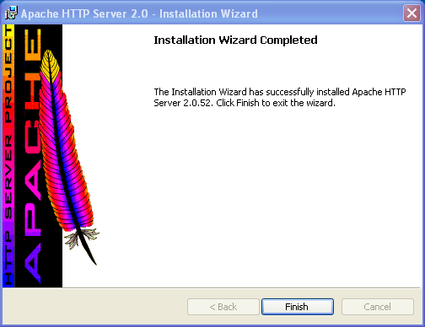

Configuring Apache
Like PHP, Apache is also entirely configured from a single text file which you will need to edit in the following way:
Step 1
Load the configuration file into a text editor by clicking on the Start Menu and selecting All Programs > Apache HTTP Server > Configure Apache Server > Edit the Apache httpd.conf Configuration file.
Step 2
Navigate to the very bottom of the file and add the following lines (cut and paste them from this document).
The lines that are highlighted in red contain references to the locations into which that you installed PHP and the SwissCenter software. If you did not use the locations shown, edit the file to reflect the locations that you did use.
Listen 8080
<VirtualHost _default_:8080>
DocumentRoot "C:\Program Files\swisscenter"
<Directory "C:\Program Files\swisscenter">
Options Indexes FollowSymLinks MultiViews
AllowOverride None
Order allow,deny
Allow from all
</Directory>
<IfModule mod_dir.c>
DirectoryIndex index.html index.php
</IfModule>
ScriptAlias /php/ "C:/Program Files/php/"
Action application/x-httpd-php "/php/php.exe"
AddType application/x-httpd-php .php
Alias /C:/ "C:/"
Alias /D:/ "D:/"
Alias /E:/ "E:/"
Alias /F:/ "F:/"
Alias /G:/ "G:/"
Alias /H:/ "H:/"
Alias /I:/ "I:/"
Alias /J:/ "J:/"
Alias /K:/ "K:/"
Alias /L:/ "L:/"
Alias /M:/ "M:/"
Alias /N:/ "N:/"
Alias /O:/ "O:/"
Alias /P:/ "P:/"
Alias /Q:/ "Q:/"
Alias /R:/ "R:/"
Alias /S:/ "S:/"
Alias /T:/ "T:/"
Alias /U:/ "U:/"
Alias /V:/ "V:/"
Alias /W:/ "W:/"
Alias /X:/ "X:/"
Alias /Y:/ "Y:/"
Alias /Z:/ "Z:/"
</VirtualHost>
Step 3
Save the File, and restart the Apache webserver by going to the Start Menu and selecting All Programs > Apache HTTP Server > Control Apache Server > Restart.

Testing your Installed software
If you followed all of the instructions above (well done!) then you can now test your configuration by opening Internet Explorer and going to the following location:
http://localhost:8080/config
If all is well, then you will see the SwissCenter Configuration Utility appear:
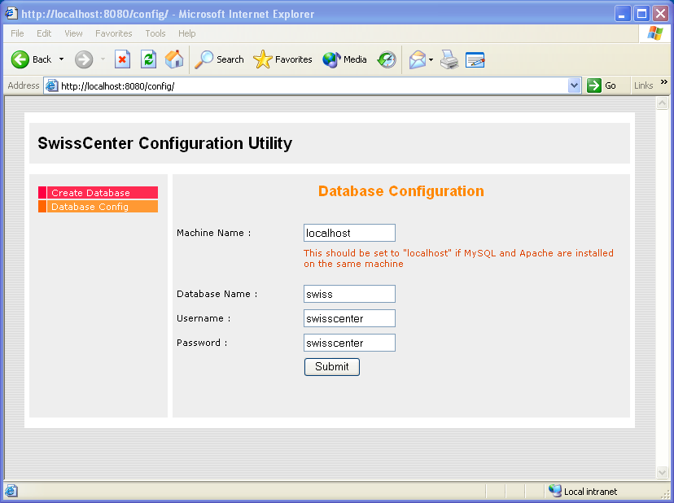

Configuring the SwissCenter Interface
At long last, you are now ready to perform a few configuration tasks for the SwissCenter software – after which you will be able to sit back and enjoy the new features the interface will bring you.
Step 1
Go to the SwissCenter Configuration Utility by entering the following URL into Internet Explorer:
http://localhost:8080/config
Step 2
As this is the first time you have run the utility, you do not have a database containing all the SwissCenter configuration and therefore you should click on the menu option "Create Database".
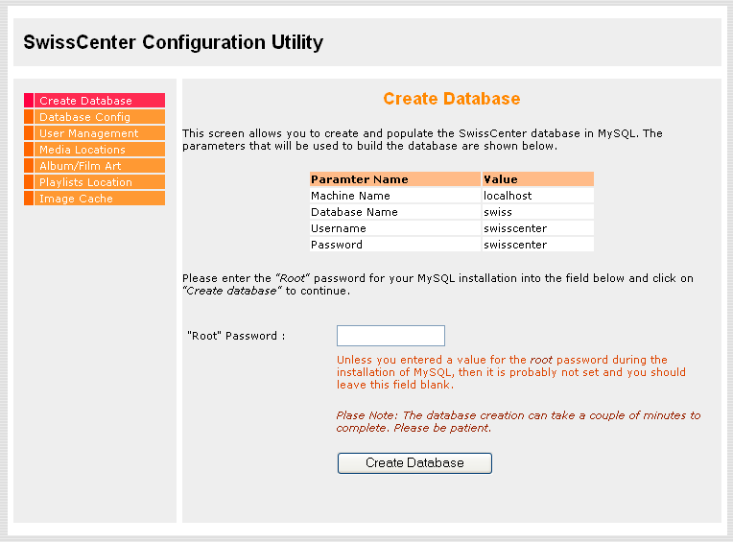
If you followed the steps in this guide, then you have not setup a root password for MySQL, and should just click on the Create Database Button. Please note that this can take approximately 60 seconds to complete.
If you are using an existing MySQL installation which has a root password assigned, then you should enter it into the box.

Step 3
When the database has been created, you will see the screen shown below which is where you specify the locations of the media files that you to be available via the SwissCenter interface.
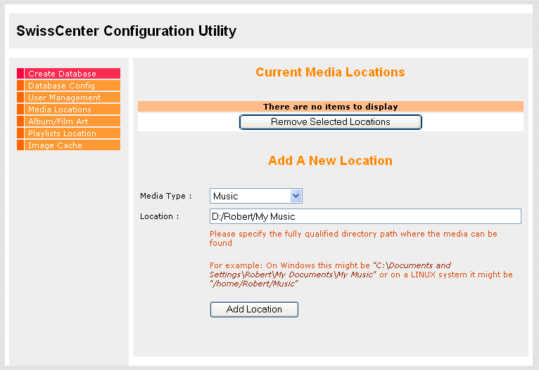
Enter a location and select the type of media files that will you want the SwissCenter to search for, and then click on the Add Location button. You can add as many locations as you wish provided that they reference local drives (C: through to Z:).
In the example above, you can see that I am adding "D:/Robert/My Music" as a location that contains Music files.
Step 4
When you have finished added all your media locations, Click on the Image Cache menu item to bring up the following screen. Enter the location where temporary image files can be written and click on the Submit button (A good location would be C:/Windows/Temp ).
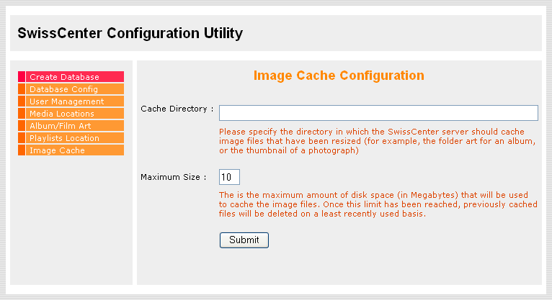

Configuring the Showcenter to use the SwissCenter Interface.
When you turn on your Showcenter box, it will not automatically detect the SwissCenter interface, and so you need to manually add it. On the screen that first appears (shown below) move the cursor over to the Add Server button and press OK on the remote control.
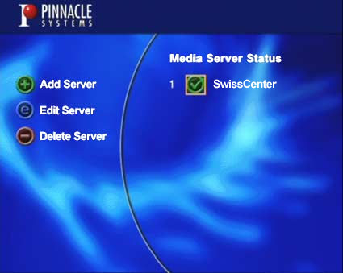
Using the numeric keys on the remote control, enter a Name for the server (eg: SwissCenter) and then the IP address of the computer that you installed Apache, MySQL, PHP and the SwissCenter software onto (making sure to add ":8080" onto the end of the IP address). Also ensure that the Always connect to this server option is checked before clicking Save.
You can find out your IP address by clicking Start > Run and entering cmd into the dialog box that appears. Pressing OK will then bring up a command window into which your should type ipconfig and press return. Your IP address will then be displayed on the screen.

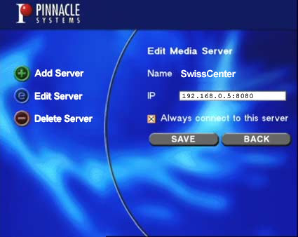

Finished!
That’s All Folks!!!
From now on, you can use the SwissCenter Interface to browse you music and movies collections, listen to some internet Radio or check the weather forecast.

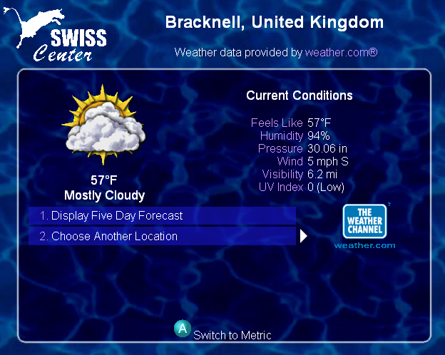 | 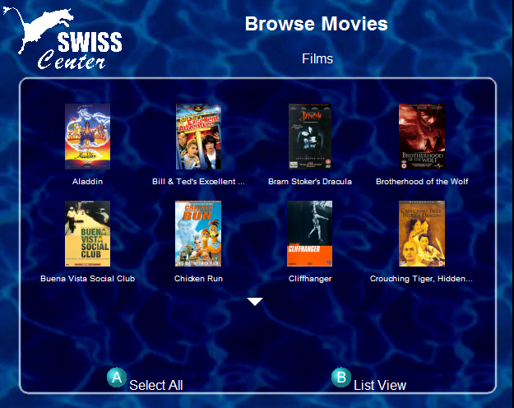
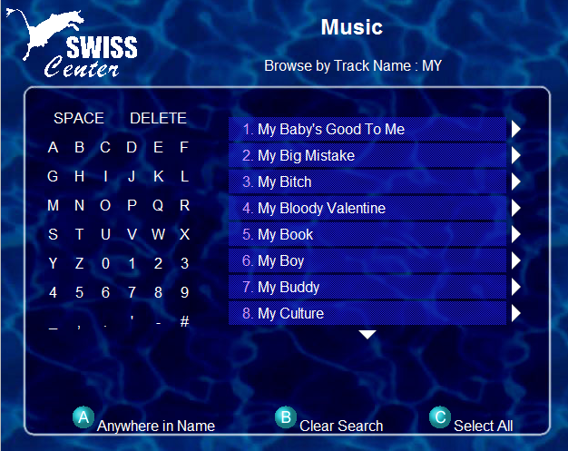 | 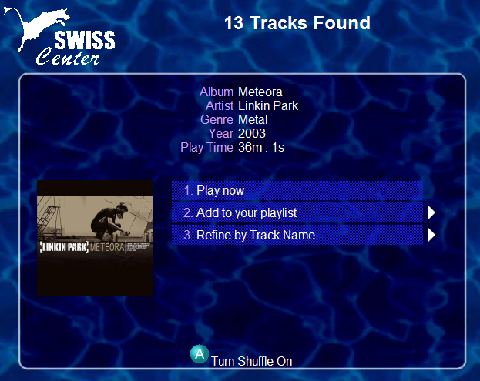
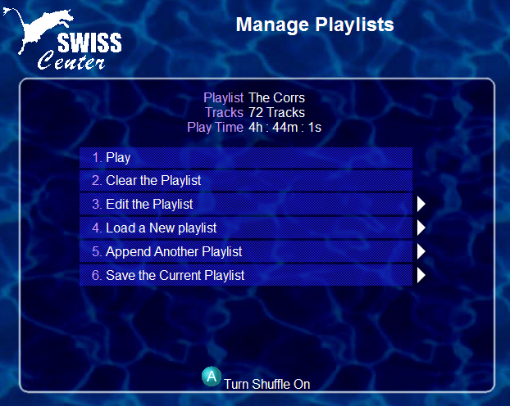 | 